SOFT COMPUTING
ASSIGNMENT -4
Perumalla Dharan
AP21110010201

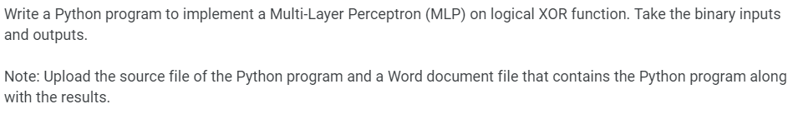

import numpy as np

class MLP:
def __init__(self, learning_rate=0.1, iterations=10000):
self.learning_rate = learning_rate
self.iterations = iterations

self.weights_input_hidden = np.random.uniform(-0.5, 0.5, (2, 2))
self.bias_hidden = np.zeros(2)
self.weights_hidden_output = np.random.uniform(-0.5, 0.5, (2, 1))
self.bias_output = np.zeros(1)

def sigmoid(self, x):
return 1 / (1 + np.exp(-x))

def predict(self, X):
hidden_input = np.dot(X, self.weights_input_hidden) + self.bias_hidden
hidden_output = self.sigmoid(hidden_input)

final_input = np.dot(hidden_output, self.weights_hidden_output) + self.bias_output
final_output = self.sigmoid(final_input)
return np.round(final_output)

def train(self, X, y):
for epoch in range(self.iterations):
for i in range(len(X)):

hidden_input = np.dot(X[i], self.weights_input_hidden) + self.bias_hidden
hidden_output = self.sigmoid(hidden_input)

final_input = np.dot(hidden_output, self.weights_hidden_output) + self.bias_output
final_output = self.sigmoid(final_input)

y_pred = np.round(final_output)

if y_pred != y[i]:

output_error = y[i] - final_output
hidden_error = output_error.dot(self.weights_hidden_output.T)

self.weights_hidden_output += self.learning_rate * np.outer(hidden_output, output_error)
self.bias_output += self.learning_rate * output_error

self.weights_input_hidden += self.learning_rate * np.outer(X[i], hidden_error)
self.bias_hidden += self.learning_rate * hidden_error

def print_weights(self):
print("Input-Hidden Weights:\n", self.weights_input_hidden)
print("Hidden-Output Weights:\n", self.weights_hidden_output)

X = np.array([[0, 0],
[0, 1],
[1, 0],
[1, 1]])

y = np.array([[0], [1], [1], [0]])

mlp = MLP(learning_rate=0.1, iterations=10000)

mlp.train(X, y)

mlp.print_weights()

predictions = mlp.predict(X)
print("Predictions after training:")
print(np.round(predictions))

Output -
